Match each term to the most appropriate concept. Not all terms are used. (2 pts each)

anguilliform
atrium
buccal forcing
bulbous arteriosus
carangiform
conus arteriosus
egg raiding
euryhaline
euryphagous carnivore
force ventilation
iteroparity
nest raiding
oscillation
osmoconformer
osmohaline
osmoregulator
ostraciform
oval
ovoviviparity
physostomous
pneumatic duct
ram ventilation
satellite
semelparity
sinus venosus
sneaker
stenohaline
stenophagous omnivore
subcarangiform
undulation
ventricle
viviparity

1. _______________________ Larval fishes are born alive. A yolk was never produced.

2. _______________________ Releases gas from swimbladder.

3. _______________________ Breathing mechanism used by strong swimmers at high speeds.

4. _______________________ Spawn once, and then die.

5. _______________________ Specific form of swimming where the energy wave begins immediately behind the head of the fish.

6. _______________________ Most common feeding mode in fishes.

7. _______________________ Young male mimics female to enter another male’s territory.

8. _______________________ Collects blood from the common cardinal vein.

9. _______________________ Osmotic concentration of hagfish equals surrounding water.

10. _______________________ Tolerates a broad range of salinity.

(GS) Answer the following two. Terms are NOT in the list above. (2.5 pts each. Really!)

10a. _______________________ a modified gill structure used by some fishes for air breathing (two possible answers)

10b. _______________________ arteries leading to the gills
11. The figure below shows an oxygen dissociation curve for a mackeral, a typical fast-swimming fish. Draw on the figure an oxygen dissociation curve that you feel accurately represents a sluggish fish living in a hypoxic environment. Justify your answer. (10 pts)

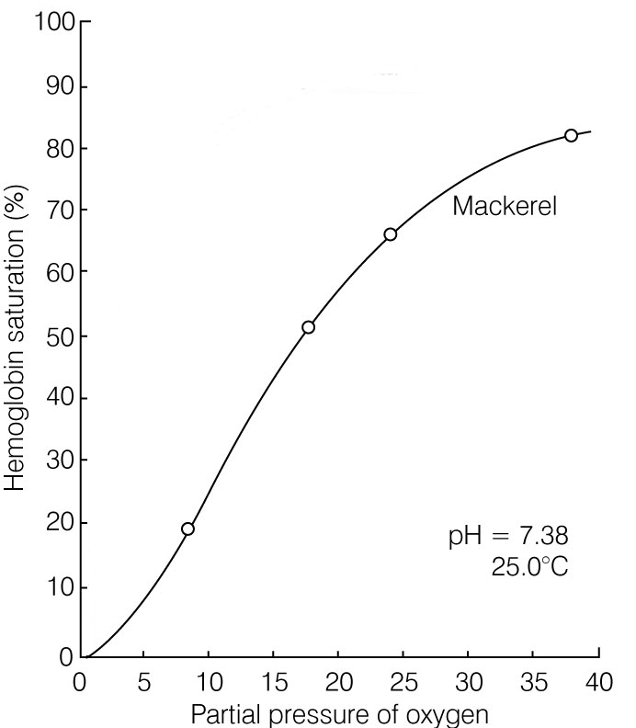

(GS) If a typical fish has a relative gill surface area of 1000, would you expect the sluggish fish to have a similar, much higher, or much lower relative gill surface area. Explain why. (5 pts)

12. Describe two strategies employed by nest-guarding males to increase chances of mating with a female. (10 pts)

13. List the four classes that together comprise “fishes.” (5 pts)

A) C)

B) D)

14. Sharks and tunas both cruise the open seas. Despite this commonality, these two fishes have very different body forms. Paul Webb, on pgs 80-81 of his Scientific American article, "Form and Function in Fish Swimming," explains why these two fishes differ so greatly. Describe one physiological, one structural and one ecological difference between sharks and tunas that explain the overall morphological difference in these cruising fishes. (15 pts)

15. Diagram and explain how a physoclistous bladder is inflated and emptied. Be sure to include all of the key structures and physiological processes. Indicate proper direction of flow for all molecules involved. Use representative values for pH and oxygen concentration to aid your explanation. (20 pts)

16. Explain how stenohaline freshwater and saltwater bony fishes maintain osmotic homeostasis. Explain for water and for relevant ions (e.g., Na⁺, Cl⁻, K⁺, Ca²⁺). Include for each when diffusion is operating and when active transport is required, and the primary regions for entry and exit of water and ions. Use illustrations to enhance your explanation. Do not include elasmobranchs or hagfishes. (20 pts)

(GS) Describe and illustrate how the circulatory/respiratory systems differ between lungfishes and teleost fishes. (15 pts)

